**Exercise 11: Online Bookstore - Integrating Spring Boot Actuator**

**Objective:**  
Enhance the monitoring and management capabilities of your bookstore's RESTful services using Spring Boot Actuator.

**1. Add Actuator Dependency**

**Steps:**

1. Adding the Spring Boot Actuator dependency to the pom.xml file.

**Dependency:**

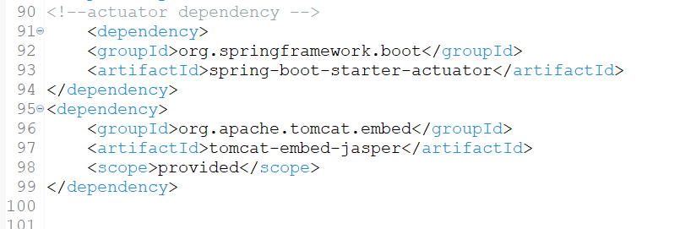

**2. Expose Actuator Endpoints**

**Description:**  
Spring Boot Actuator provides a set of endpoints that help you monitor and manage application. One can enable and customize these endpoints according to requirements.

**Steps:**

**Configure Actuator Endpoints:**

* + 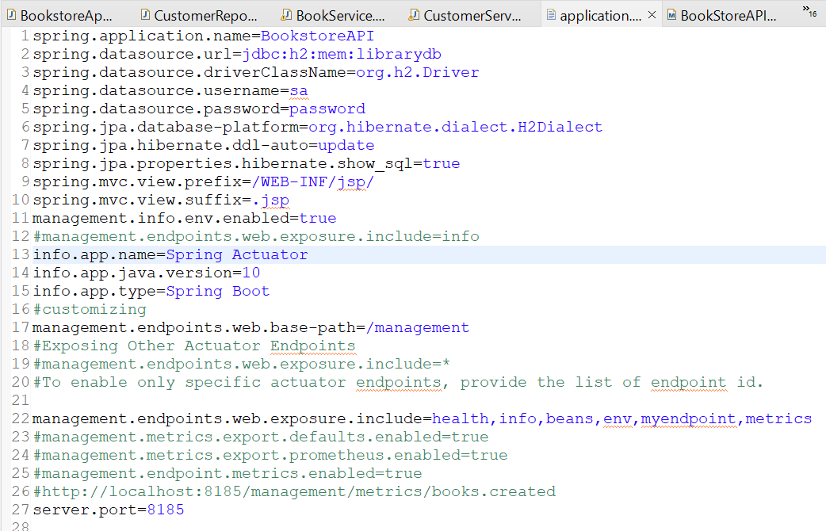Modified the application.properties to customize endpoints are enabled:

**3. Custom Metrics**

**Description:**  
Spring Boot Actuator supports custom metrics through the MeterRegistry.  
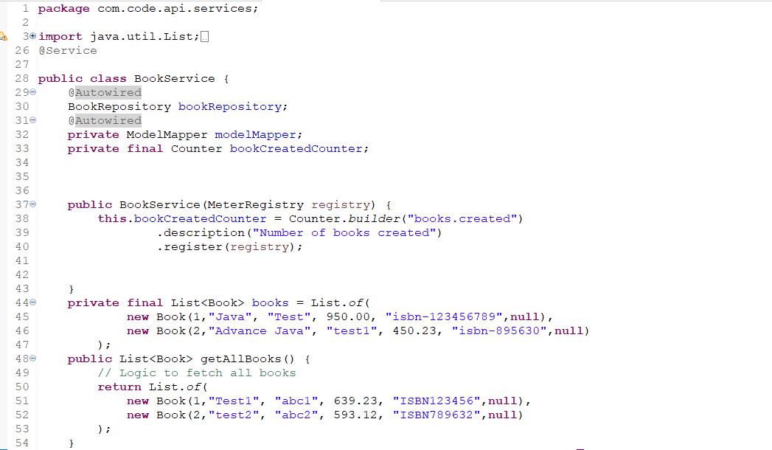

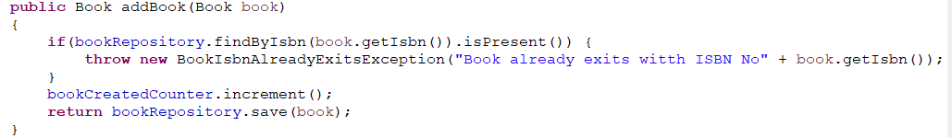

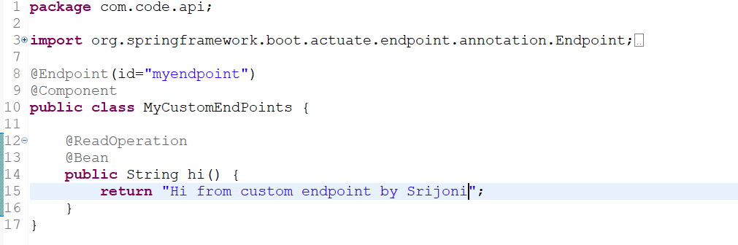

**Output (Metrics):**

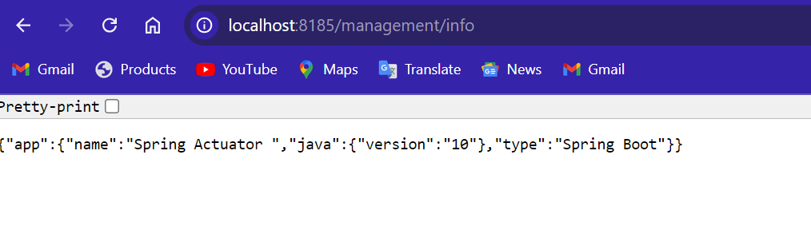

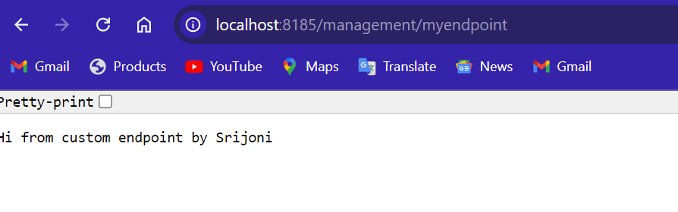

Added Books:

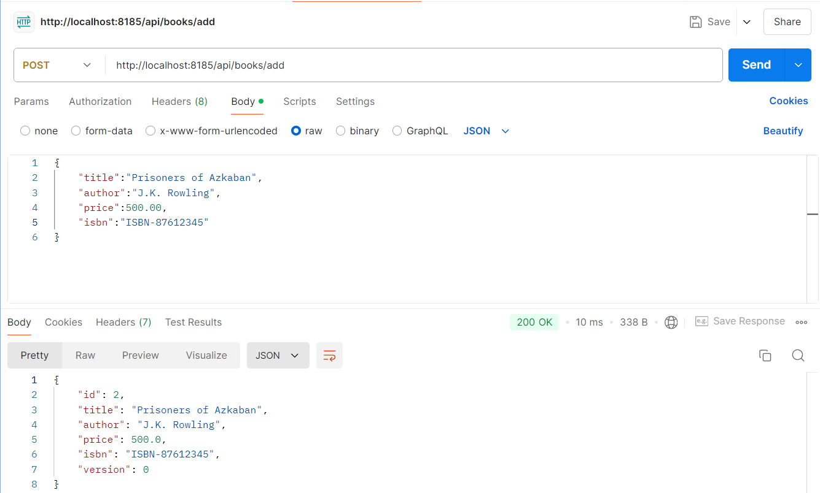

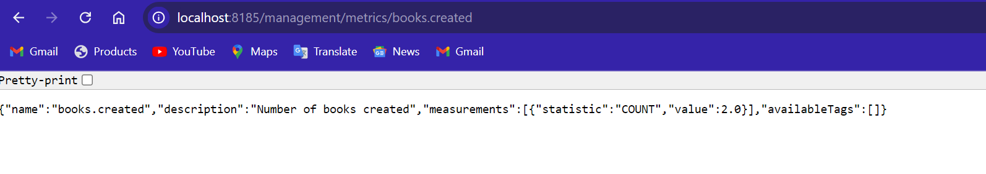Metrics checked:

